**Cambridge Causeway**

Easter Readings

April 2021

Wishing you a very happy Easter from Chrissy Cole

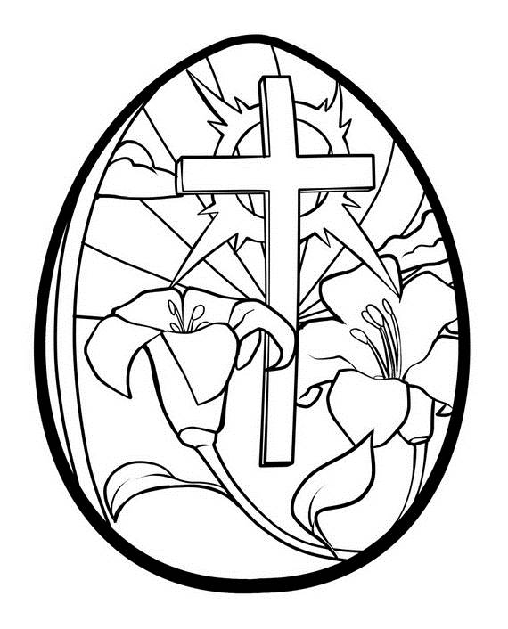

**Thursday 1st April - Maundy Thursday**

**Reading – Mark 14:32-36**

Jesus and his followers went to a place names Gethsemane. He said to them, ”Sit here while I pray.” But he told Peter, James and John to come with him. He began to be very distressed and troubled, and he said to them, “My heart is heavy with grief, I feel as if I am dying. Wait here and stay awake.”

Jesus went on a little further from them, fell to the ground and prayed. He asked that, if possible, he would not have this time of suffering. He said, “Abba, Father! You can do all things. Don’t make me drink from this cup. But what you want, not what I want.”

Then he went back to his followers and found them sleeping.

**Thinking about the passage**

On Maundy Thursday we remember how Jesus had a special meal with his friends. After the meal, they went out to the garden called Gethsemane. Jesus knew he was going to die on a cross and maybe he felt frightened. He is human like us and he felt fear and pain like we do. But he was determined to do what God wanted, not what he wanted.

Meanwhile, where were his friends? Sadly, they had fallen asleep! They were no help to him at all.

**Prayer**

Thank you, Jesus, that you did not give up when things got hard. Help us to follow you even when things are difficult. Help us to watch and pray. Amen

**Friday 2nd April – Good Friday**

**Reading – Mark 15:33-34**

At noon, the whole country became dark. This darkness continued until three o’clock. At three o’clock Jesus cried out loudly, “My God, my God, why have you left me alone?”

**Thinking about the passage**

Jesus was arrested in the Garden of Gethsemane and taken to a sort of court where they decided he should be put to death. The Romans then nailed him to a cross.

When Jesus cried out “My God, my God, why have you left me alone?” he was thinking about Psalm 42. Although he knew that God would never leave him, in the darkness on the cross, it must have felt as if he was on his own. Maybe the thinking about the Psalm helped him.

Sometimes we can feel that we are on our own. Because Jesus has been through it first, he knows how we feel, and he can help us. We know that on the cross he carried all our pain and suffering, and all the things we have done wrong. When we choose to follow him and say sorry to God, we can have forgiveness and new life.

**Prayer**

Thank you, Jesus, that you died on the cross for me, so that God could forgive me for all the wrong things I have done. Thank you that you love me so much that you were willing to go through such pain and suffering for my sake.

Amen

**Sunday 4th April – Easter Sunday**

**Reading – Mark 16:2a, 5-6**

Very early in that day, the first day of the week, the women were going to the tomb. The women walked into the tomb and saw a young man there wearing a white robe. He was sitting on the right side of the tomb. The women were afraid.

But the man said, “Don’t be afraid. You are looking for Jesus from Nazareth, the one who was killed in a cross. He has risen from death! He is not here. Look, here is the place they put him when he was dead.”

**Thinking about the passage**

After Jesus died on Good Friday, his body was taken down from the cross and put in a tomb, which was like a stone cave. A big stone was rolled across the entrance. The women who followed him went to the tomb on Sunday morning. How would they move the big stone? But when they got there, the stone was already moved and there sat the angel! Jesus’ body was not there! The tomb was empty! He had risen from the dead and was alive! It must have been hard to understand because it had never happened before. We know that Jesus is alive today. He is in heaven with God the Father, and he prays for us and sends his Holy Spirit so that we will have the power and strength to follow him.

**Prayer**

Father God we praise you that you raised Jesus from the dead. Thank you that in him, we too can have new life.

Help us to praise him on this special day. Amen